Project Design Phase-II
Data Flow Diagram & User Stories

Date | 31 January 2026
Team ID
Project Name | Global EV Market Intelligence Dashboard
Maximum Marks | 4 Marks

Data Flow Diagrams:
A Data Flow Diagram (DFD) is a traditional visual representation of the information flows within a system. A neat and clear DFD can depict the right amount of the system requirement graphically. It shows how data enters and leaves the system, what changes the information, and where data is stored.
DFD Symbol Legend
Symbol | Name | Description
Oval / Rounded  shape | External Entity | A person, organization, or system outside the project that sends or receives data (e.g., Customer, Payment Gateway).
Rectangle with  numbered header | Process | An activity that transforms incoming data into outgoing data (e.g., Validate Request, Process Order).
Rectangle (solid fill, no number) | Data Store | A place where data is held for later use (e.g., Customer Database, Inventory).
Labeled arrow | Data Flow | The movement of data between entities, processes, and data stores, labeled with what data is being passed.

DFD Level 0 (Industry Standard)

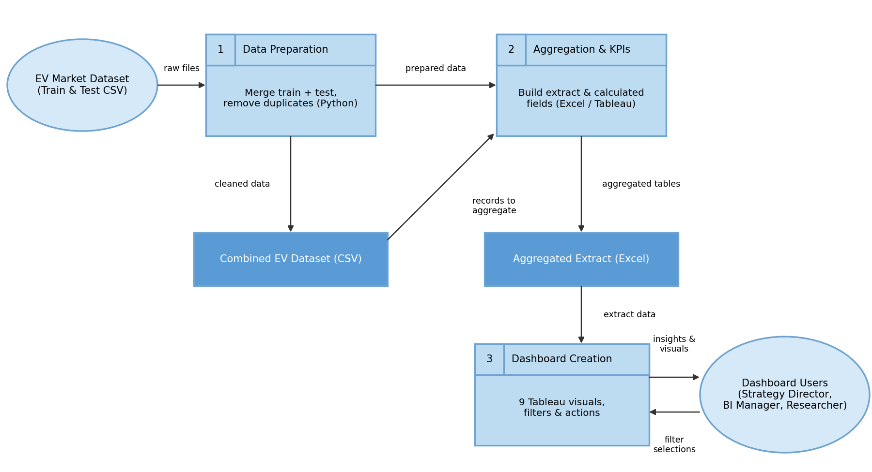

User Stories
Use the below template to list all the user stories for the product.
User Type | Functional Requirement (Epic) | User Story Number | User Story / Task | Acceptance criteria | Priority | Release
Market Strategy Director | Sales Analysis | USN-1 | As a Market Strategy Director, I can view total sales by vehicle category so that I can identify the top-selling segments. | I can see a ranked bar chart of sales for all 15 categories | High | Sprint-1
 | Product Performance | USN-2 | As a Market Strategy Director, I can compare average driving range across vehicle categories. | I can see a range bar chart with an average reference line | Medium | Sprint-1
 | Market Trends | USN-3 | As a Market Strategy Director, I can view sales trends by model year to spot high-growth segments. | I can see a line per category with year-over-year growth in the tooltip | Medium | Sprint-2
 | Customer Satisfaction | USN-4 | As a Market Strategy Director, I can view customer ratings by category and battery type. | I can see a heat map of average ratings | Medium | Sprint-2
Business Intelligence Manager | Manufacturer Analysis | USN-5 | As a BI Manager, I can view the top 10 manufacturers and their market share. | I can see a top 10 bar chart and a market-share treemap | High | Sprint-1
 | Geographic Analysis | USN-6 | As a BI Manager, I can see sales by manufacturing country on a map. | I can see a filled map with sales and ratings on hover | Medium | Sprint-2
 | Battery Technology | USN-7 | As a BI Manager, I can see the share of each battery technology. | I can see a chart showing NMC, LFP, NCA, Sodium-Ion and Solid-State shares | High | Sprint-1
Research Analyst | Battery & Range Research | USN-8 | As a Research Analyst, I can compare battery capacity with driving range. | I can see a scatter plot with a trend line, colored by battery type | High | Sprint-1
 | Filtering & Exploration | USN-9 | As a Research Analyst, I can filter the dashboard by model year, category and battery type. | Selecting a filter updates all charts | High | Sprint-2
Administrator | Data Management | USN-10 | As an Administrator, I can refresh the data extract with new records. | The updated file loads and all visuals refresh | Medium | Sprint-3
 | Report Export | USN-11 | As an Administrator, I can export the dashboard as an image or PDF. | A PNG or PDF of the dashboard is created | Low | Sprint-3
 | Dashboard Maintenance | USN-12 | As an Administrator, I can update calculated fields and filters to keep results accurate. | Updated measures show correct values on the dashboard | Medium | Sprint-3

